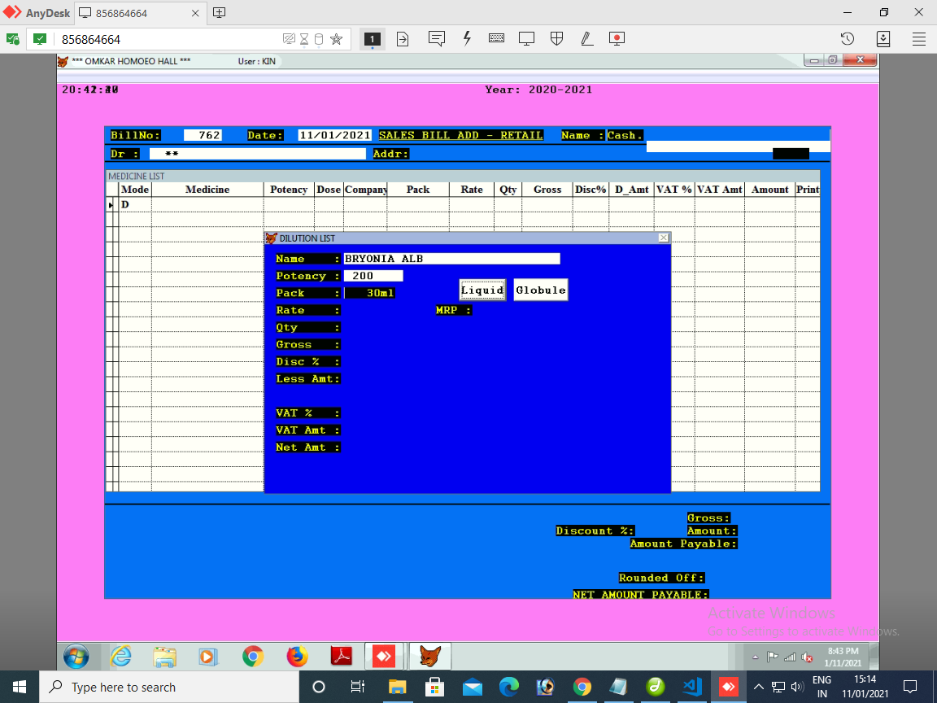

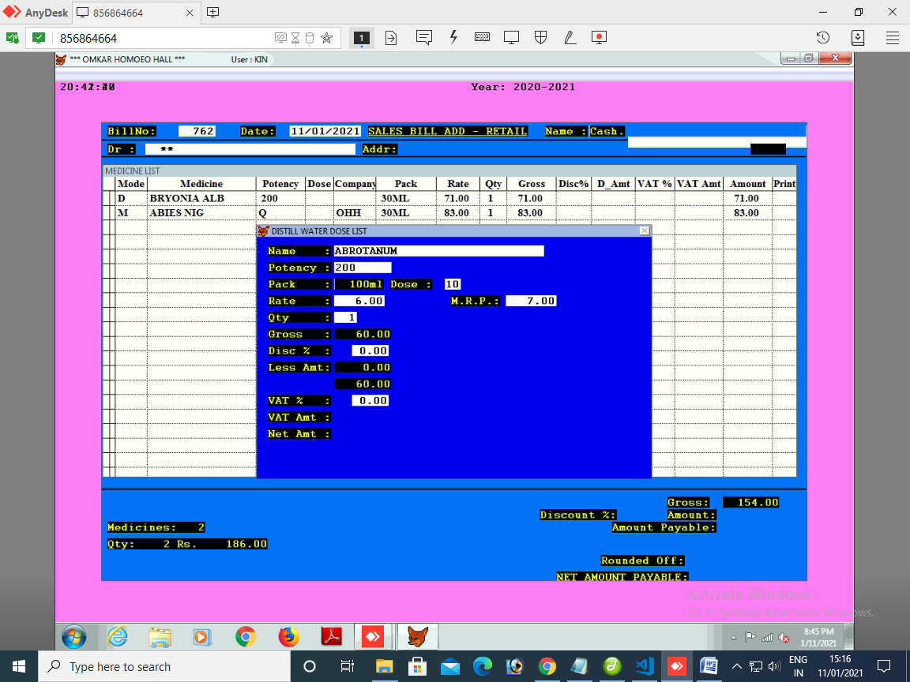

sugar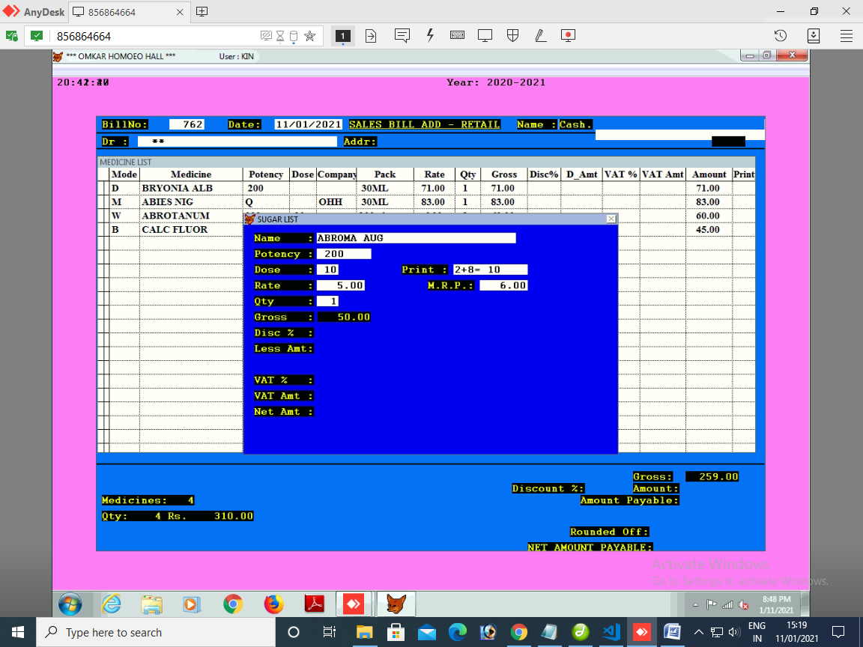

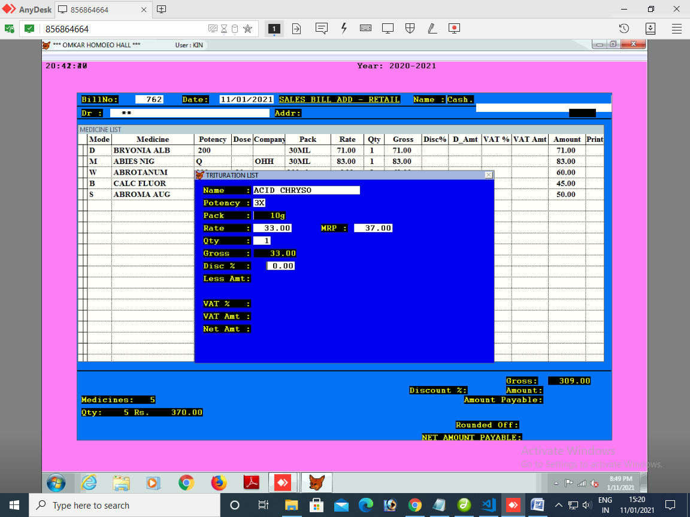

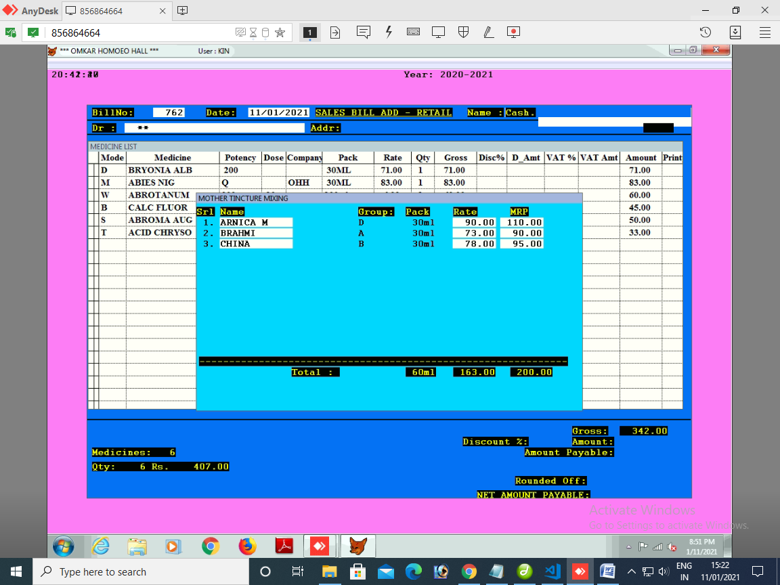

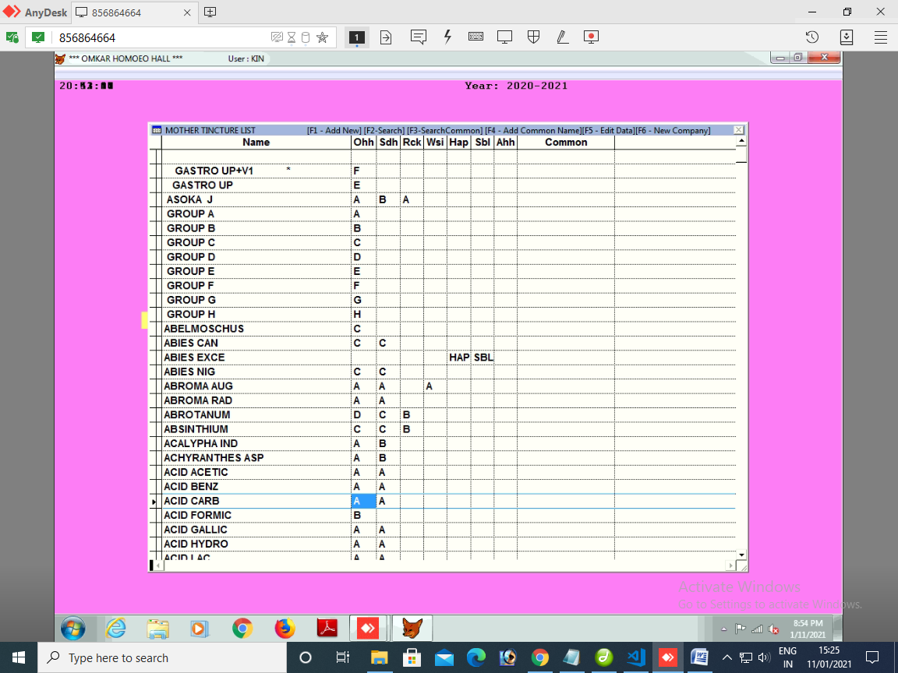

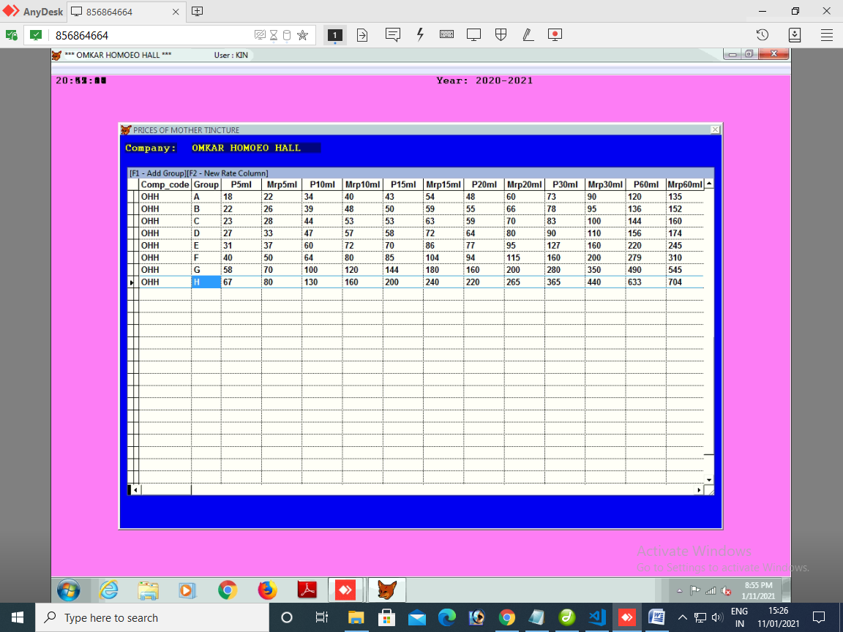

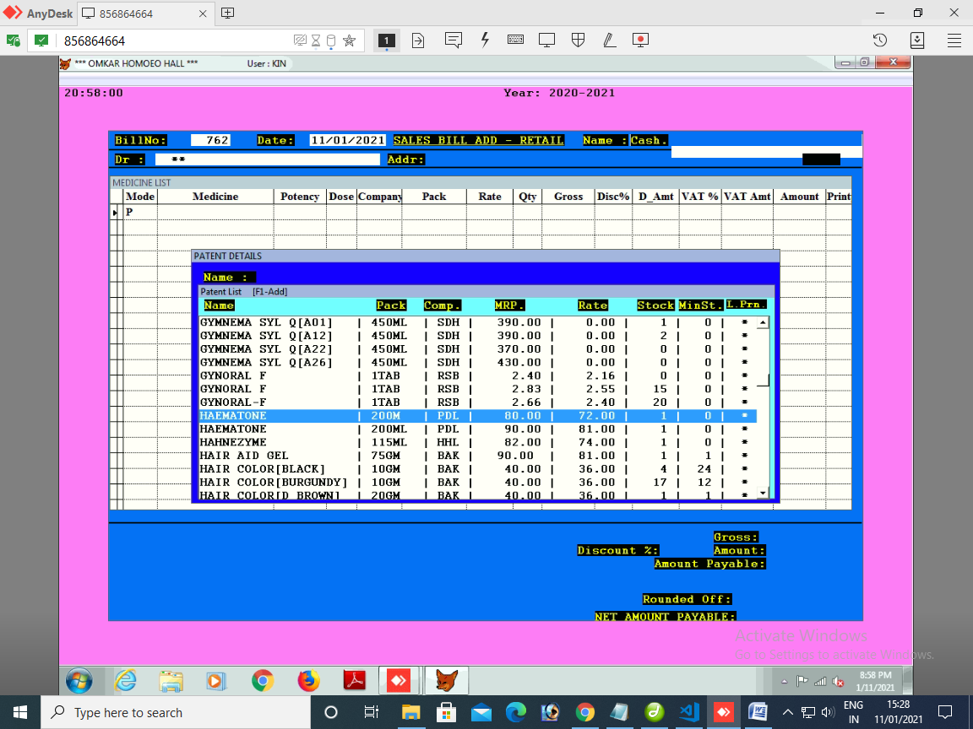

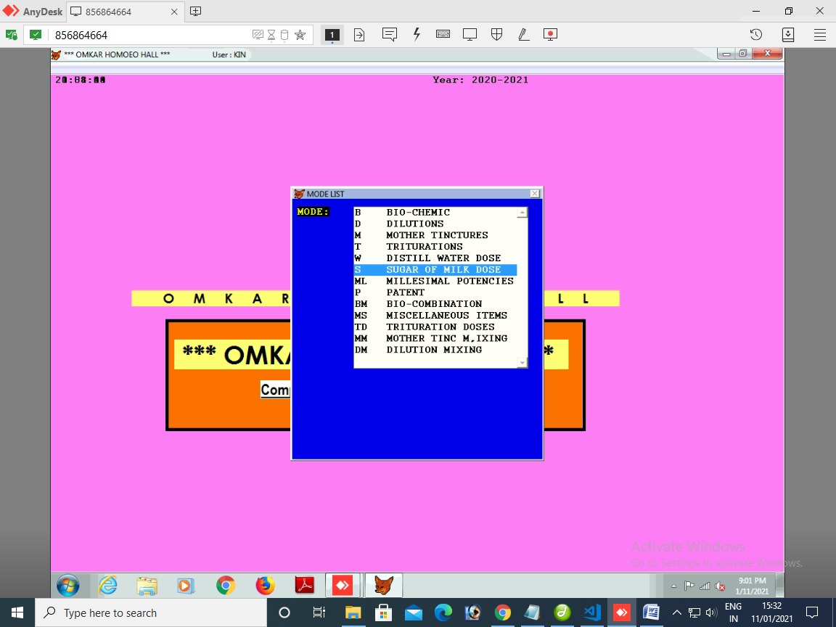

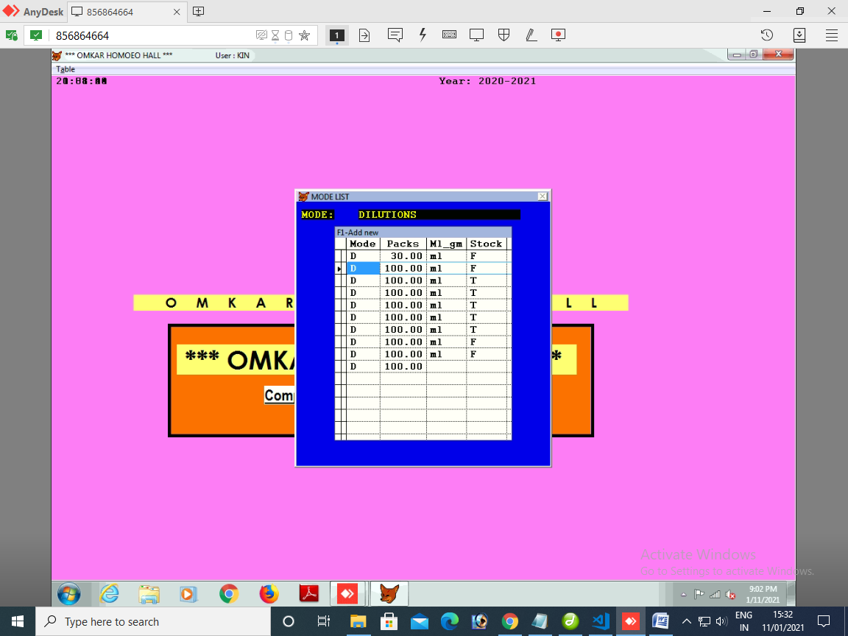

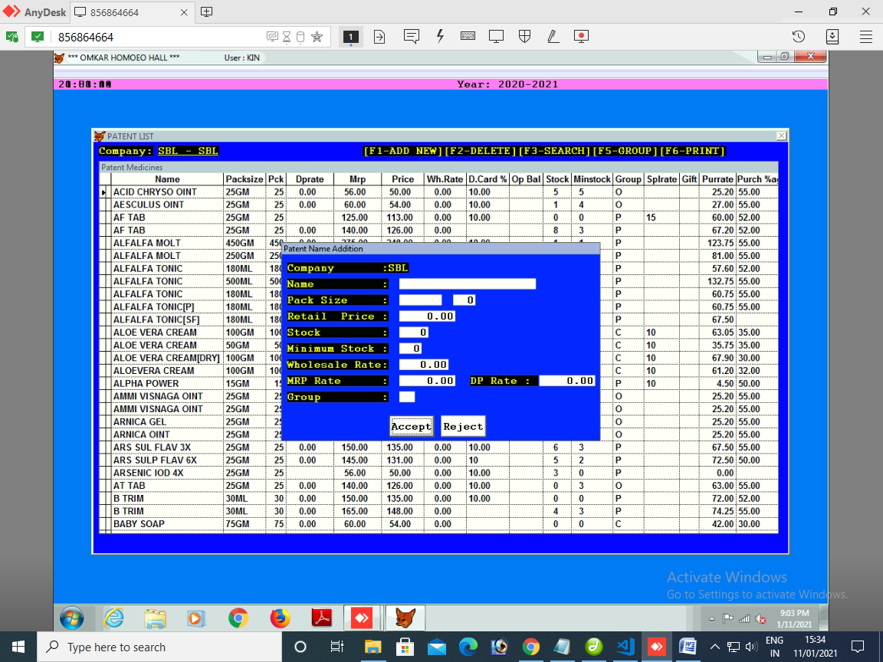

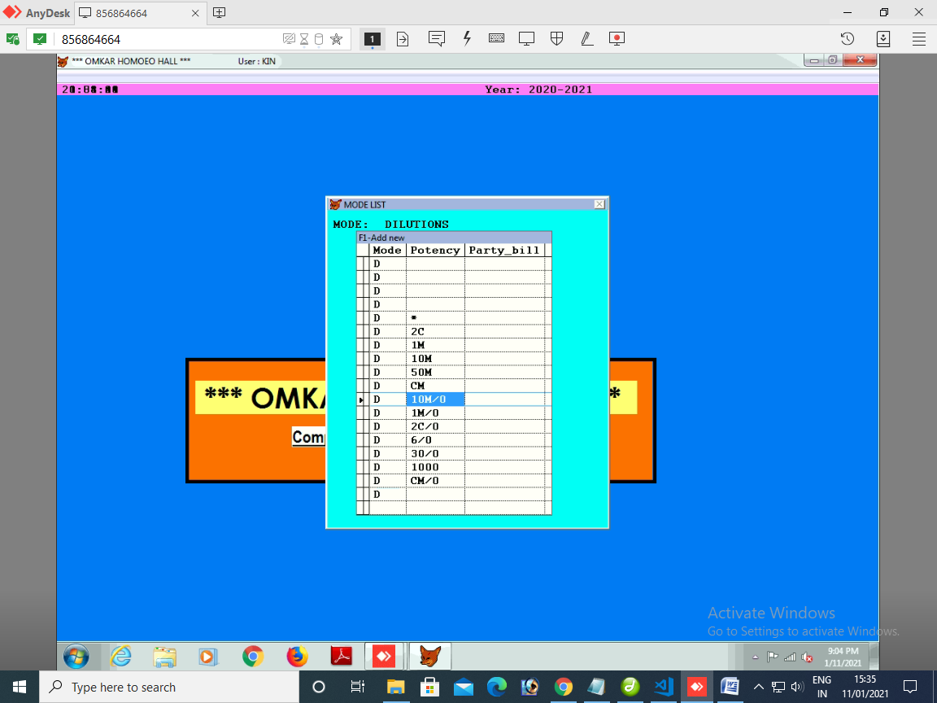

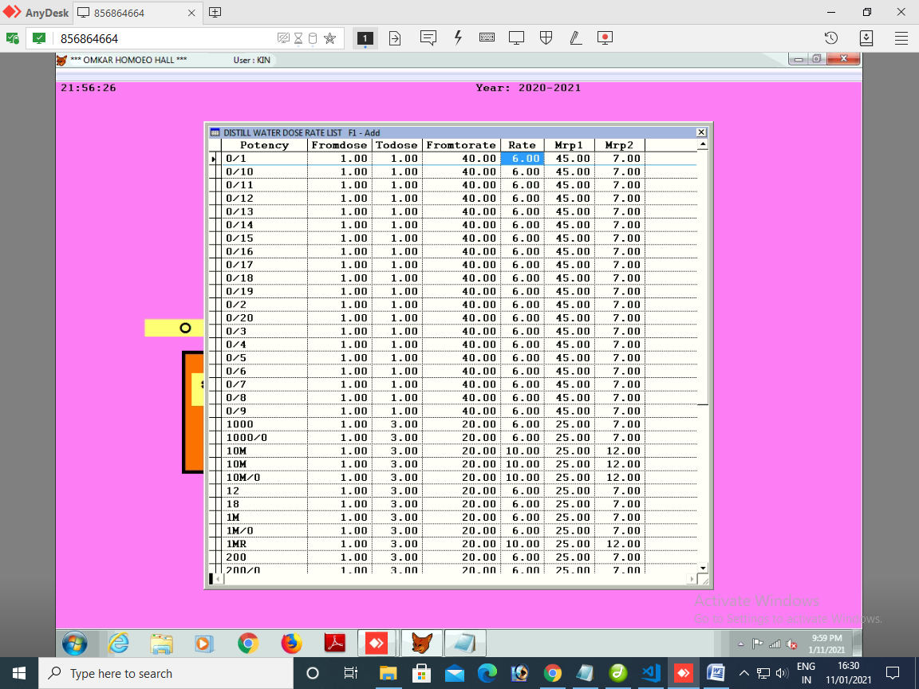

**MASTER SETUP**

**MOTHER LIST,TRITUTION**

GROUP A,B,C D,E,F,H-->POTENCY

GROUP->PRODUCT->POTENCY->PACK -->MRP AND PRICE

ARNICA A Q 30ML -> 60{MRP) PRICE (50)

ARNICA A 2X 30ML -> 65{MRP) PRICE (55)

**DILUTION,BIOCHEMIC**

PRODUCT NAME ->POTENCY->PACK-> RATE ,MRP

**WATER**

PRODUCT NAME ->POTENCY->PACK-DOSE WISE-> RATE ,MRP

**SUGAR OF MILK**

PRODUCT NAME ->POTENCY->DOSE WISE-> RATE ,MRP

**PATENT**

PRODUCT NAME ->RATE,MRP

**TABLE STRUCTURE**

|  |  |  |  |  |  |  |  |
| --- | --- | --- | --- | --- | --- | --- | --- |
| ID | GROUP_ID | PRODUCT_ID | POTENCY_ID | PACK_ID | DOSE_ID | RATE | MRP |

SELECT GROUP

|  |  |  |  |  |
| --- | --- | --- | --- | --- |
| **POTENCY** | **PACK** | **DOSE** | **RATE** | **MRP** |
| 2X | 5ML | 1 | 10 | 15 |
| 2X | 10ML | 1 |  |  |
|  |  |  |  |  |